SENATE POLICY 3-29

Motion: to approve the Policy on the Use of Human Subjects Passed at the May 4, 2004 meeting of the Academic Senate.

Approvals:

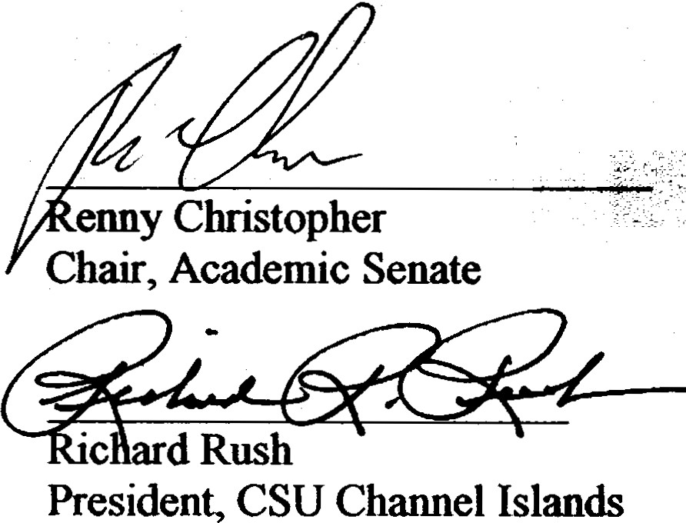Date

-

Date!

Division of Academic Affairs
Approved By: Academic Senate
May 4, 2004
Policy Number: SP 03-29 Effective Date: Fall 2004 Page l of 8

Policy on Use _of Human Subjects

USE OF HUMAN SUBJECTS
Purpose: This policy provides guidelines for the use of human subjects in research. Its purpose is to provide information and set forth policies and procedures to insure that human subjects participating in research activities conducted at and/or sponsored by the University or its auxiliaries are protected from undue risks and deprivation of personal rights and dignity.

Background: This is a new policy Accountability:
Applicability: This policy applies to all university faculty, staff and students who may conduct research involving human subjects, except where the policy states that certain forms of data collection are exempt.

Policy:
- Purpose
The purpose of this document is to provide information and set forth policies and procedures to insure that human subjects participating in research activities conducted at and/or sponsored by the University or its auxiliaries are protected from undue risks and deprivation of personal rights and dignity.
- Authority
Section 474 of the National Research Act, Public Law 93-348, dated July 12, 1974, calls for all institutions applying for federal funding to have on-site permanent review boards which "review biomedical and behavioral research involving human subjects in order to protect the rights of the human subjects on such research."
- Institutional Responsibilities
At California State University Channel Islands (CSU CI), the administrative authority for the protection of human subjects, in funded as well as non-funded research, has been delegated to the Provost. The President has appointed the Institutional Review Board for the Rights of Human Subjects, which works under the sponsorship of the Office of Research and Sponsored Programs (ORSP) to ensure the protection of the rights of human subjects and serves as the University's Institutional Review Board (IRB) for purposes of local, state, and federal requirements. The Chairperson of the IRB is appointed

Division of Academic Affairs
Approved By: Academic Senate
May 4, 2004
Policy Number: SP 03-29 Effective Date: Fall 2004 Page 2 of 8

Policy on Use _of Human Subjects

by the Provost to guide IRB activities and to ensure compliance with all relevant policies, procedures, and government regulations. The Vice­ President for Academic Affairs or designee serves as the University's Institutional Signatory Official for purposes of federal regulation. The IRB's charge is to facilitate scientific inquiry while preserving the dignity of individuals and the rights of various social groups. It has the ultimate responsibility to determine risk with regard to human subject research conducted at and/or under the sponsorship of the University or its auxiliaries.
- Structure of the IRB
Incompliance with federal regulation, the IRB: Must be comprised of at least five persons with varying backgrounds to assure complete and adequate review of activities commonly conducted by the institution. Must be sufficiently qualified through the experience and expertise of its members, and the diversity of its members (including consideration of race, gender, and cultural backgrounds and sensitivity to such issues as community attitudes) to promote respect for its advice and counsel in safeguarding the rights and welfare of human subjects. Must not consist entirely of men or entirely of women, nor can it consist entirely of members of one profession. Must include at least one member whose primary concerns are in scientific areas and at least one member whose primary concerns are in nonscientific areas. Must have at least one member who is not otherwise affiliated with the institution and who is not part of the immediate family of a person who is affiliated with the institution. Must not have a member participate in its initial or continuing review of any project in which the member has a conflicting interest, except to provide information requested by the IRB. May, at its discretion, invite individuals with competence in special areas to assist in the review of issues that require expertise beyond or in addition to that available on the IRB. These individuals may not vote with the IRB.
- Education
The IRB Chairperson, members, staff, and human subject research investigators must complete appropriate education related to the protection of human subjects before reviewing or conducting human subject research. The IRB Chairperson will make the determination as to what constitutes appropriate education and whether it has been completed. The IRB Chairperson will ensure the existence of adequate education and oversight mechanisms (appropriate to the nature and volume of the research being conducted) to verify that IRB members, staff, investigators and key personnel maintain continuing knowledge of, and comply with, relevant federal regulations, Office for Human Research Protections (OHRP) guidance, other applicable guidance, state and local law, and IRB determinations and policies for protection of human subjects.

Division of Academic Affairs
Approved By: Academic Senate
May 4, 2004
Policy Number: SP 03-29 Effective Date: Fall 2004 Page 3 of 8

Policy on Use _of Human Subjects

USE OF HUMAN SUBJECTS
- Human Subject Involvement
- There is human subject involvement when human beings are asked to participate:
- Physically in an activity or to donate their tissue, organs, fluids, and other bodily material.
- When information is sought from them directly (as through interview, questionnaire) or indirectly (as through observation).
- When information concerning specific, individually identifiable human beings is asked for from third parties whether through access to files, data banks, or other means-or through direct inquiry of third parties concerning the individuals in question.
- Research proposals for which the question of human subject involvement is itself uncertain or ambiguous must be submitted for review.
- Ethical Principles For The Use Of Human Subjects In Research
It is the responsibility of the individual investigator to ensure that appropriate ethical principles are adhered to in the conduct of research involving human subjects. The investigator is responsible for the ethical treatment, and prevention of negligent treatment, of research subjects by collaborators, assistants, students, or employees who are assisting in the research of the investigator, as well as his or her own behavior. The University is guided by the ethical principles regarding all research involving human subjects as set forth in the report of The National Commission for the Protection of Human Subjects of Biomedical and Behavioral Research entitled "Belmont Report: Ethical Principles and Guidelines for the Protection of Human Subjects of Research." The University is also guided by the Nuremberg Code and the World Medical Association Declaration of Helsinki: "Recommendations Guiding Medical Doctors in Biomedical Research Involving Human Subjects." The primary ethical principles that must be considered in all research involving human subjects include: Ensuring the participation of human subjects is voluntary, occurring as a result of free choice, without compulsion or obligation, based upon disclosure of relevant information in a clear, concise, and understandable way. Protecting the subjects from physical and mental discomfort, harm, or danger.
Designing projects with the intent that the knowledge gained will benefit the subjects and/or a larger community and outweigh any risk to the subjects. Conducting research in a fair and equitable manner, so that selection of subjects does not overburden, over utilize, unfairly favor or discriminate against any subject pool. Honoring commitments made to subjects, contributors, or collaborators in a research project relative to its design and the confidentiality of any information about subjects gathered during the investigation.

Division of Academic Affairs
Approved By: Academic Senate
May 4, 2004
Policy Number: SP 03-29 Effective Date: Fall 2004 Page 4 of 8

Policy on Use _of Human Subjects

VIU. Scope of the Review
- Under Auspices of the University
I . When human subject research is conducted and/or sponsored by University employees, auxiliary employees, and/or students (including student/faculty collaborative research) under the auspices of the University, a protocol describing the research must be submitted to the IRB for review and approval.
A.2. Activities that are sponsored by an outside agency and which utilize CSU Channel Islands employee time, facilities, resources and/or students are considered to be conducted under the auspices of both CSU Channel Islands and the outside agency. In this case, approval must be obtained from the IRB of both CSU Channel Islands and the outside agency.
- Extramural Support
Researchers requesting extramural support for activities involving human subjects under the auspices of the University are required to contact the Office of Research and Sponsored Programs to obtain campus endorsement of their proposal. Approval of the use of human subjects prior to submission of the proposal may be required at the discretion of the ORSP for studies deemed to entail high risk to the subjects. For all other proposals, approval of the use of human subjects must be requested at least one month prior to commencement of the project.
- Review Process
All research involving human subjects which is designed, in whole or in part, to develop or contribute to generalized knowledge require IRB review. The type of review required depends upon the nature of the research, the subjects, and the risk imposed on the subjects.
Research intended solely for classroom use which has no intended disclosure or publication purposes and conference/ workshop evaluation surveys do not require IRB review. Similarly, institutional and program evaluation intended solely for administrative and quality assurance research purposes do not require IRB review. All other research must receive IRB approval prior to initiation whether it is conducted by faculty, students, or staff.
A. Review Categories
Research involving the use of human subjects falls into three review categories: (1) research that qualifies for exemption from federal regulations; (2) research that qualifies for expedited IRB review; and (3) research that requires full IRB review. Information on the circumstances that qualify a research study for a particular review category is listed in the Code of Federal

Division of Academic Affairs
Approved By: Academic Senate
May 4, 2004
Policy Number: SP 03-29 Effective Date: Fall 2004 Page 5 of 8

Policy on Use _of Human Subjects

Regulations, Title 45, sections 46. l Ol .2(b) and 46.110, and provided as an Appendix to the IRB approval application form that may be obtained from ORSP or may be downloaded from the ORSP web page at www.csuci.edu/academics/programs/fundedprograms.htm. In all cases investigators must submit a protocol and receive approval, even if the proposed research is perceived by the investigator to be exempt from federal regulations. The review procedure and the length of time required for review varies with each category, 1) Exempt/Expedited and 2) Full-Review. Exempt/Expedited reviews are conducted solely by the IRB Chairperson;

USE OF HUMAN SUBJECTS
IRB members are advised on a quarterly or as necessary basis of protocols approved via exempt/expedited reviews. An adequate standard of informed consent and confidentiality must be maintained and reviewed for all research involving human subjects, even that which is exempt from federal regulations. See item B.2 under section X. Application and Reporting Details, for details.
- IRB Review Criteria
The IRB review process is not intended to judge the nature of a research topic, as long as the rights and welfare of the subjects are adequately protected and the protocol will be conducted in full compliance with Department of Health and Human Services (DHHS) regulations.
In order to approve a research project involving human subjects, the IRB must assure itself of the following: Risks to subjects are minimized: (i) by using procedures which are consistent with sound research design and which do not necessarily expose subjects to risk, and (ii) whenever appropriate, by using procedures already being performed on the subjects for diagnostic or treatment purposes. Risks to subjects are reasonable in relation to anticipated benefits, if any, to subjects, and the importance of the knowledge that may be reasonably expected to result.
Selection of subjects is equitable. Informed consent will be sought from each prospective subject or the subject's legally authorized representative. Informed consent will be appropriately documented. When appropriate, the research plan makes adequate provision for monitoring the data collected to ensure the safety of subjects. When appropriate, there are adequate provisions to protect the privacy of subjects to maintain the confidentiality of data.
- Notification of Approval or Disapproval
The signature of the IRB Chairperson on the investigator's protocol indicates approval of research. The IRB will notify investigators of disapproval in writing, including a statement of the reasons for its decision. The investigator will be given an opportunity to respond in person or in writing.

Division of Academic Affairs
Approved By: Academic Senate
May 4, 2004
Policy Number: SP 03-29 Effective Date: Fall 2004 Page 6 of 8

Policy on Use _of Human Subjects

- Suspension/termination of IRB approval
The IRB has the authority to suspend or terminate approval of research that is not being conducted in accordance with its requirements or that has been associated with unexpected serious harm to subjects. Suspensions or terminations of approval will be made in writing, will include a statement of the reasons for the IRB's actions, and will be reported to the investigator, the Institutional Signatory Official, and, in instances involving federal support, the department or agency head.
- Application and Reporting Procedures
Researchers are required to submit an application describing their proposed research or activity involving human subjects. Student non-collaborative research protocols must first be submitted to the faculty sponsor and to the department review committee, if one exists, for review and approval.
- Deadlines for Submission of Application
The application must be received in the Office of Research and Sponsored Programs one month before the research is scheduled to begin.
- Documents Required
The IRB requires two documents for each new study involving human subjects: (1) the IRB Application form, (2)) a copy of the consent form or request for waiver of written informed consent. The Application and Consent forms are self-explanatory and are available from the Office of Research and Sponsored Programs, Professional Building, Room 202. The forms and application guidelines may also be downloaded from the ORSP web page http//:www.csuci.edu/orsp.
  - l . The Application
The application is a statement of the investigator's responsibilities toward the human subjects involved in the proposed research and must address the items and issues delineated by requirements in the application packet. The application should be limited to five or fewer pages. Extramural grant applications typically do not address themselves to the issues of concern to the IRB and should not be submitted in lieu of a completed application.
B.2 The Consent Form
Except as provided elsewhere in this policy, no investigator may involve a human being as a subject in research unless the investigator has obtained the legally effective informed consent of the subject. Informed consent means the knowing consent of an individual or his/her legally

Division of Academic Affairs
Approved By: Academic Senate
May 4, 2004
Policy Number: SP 03-29 Effective Date: Fall 2004 Page 7 of 8
Policy on Use of Human Subjects
,....... 1; .. .. --- • - -, + ,·.,'}'..·- • : •
- •• ' ,;.-,, . •• .. - •• ; , ft . . ...... ,

authorized representative so situated as to be able to exercise free power of choice without undue inducement or any element of force, fraud, deceit, duress, or other form of constraint or coercion. A sample consent form is included in the application packet available from ORSP.
In lieu of a consent form, the investigator may submit a request for waiver or alteration of the signed informed consent requirement, with sufficient information to enable the IRB Chairperson to determine (i) the research involves minimal risk to the subjects, (ii) the waiver or alteration of requirement will not adversely affect the rights and welfare of the subjects; (iii) the research could not practically be carried out without the waiver or alteration; and (iv) whenever appropriate, the subjects will be provided with additional pertinent information after participation. At the discretion of the IRB Chairperson, the signed consent requirement may be waived, or the investigator may be required to provide subjects with a written statement regarding the research instead of obtaining a signed consent form. Additional supporting documents may be included such as questionnaires, signed letters of participation and agreement by participating outside institutions or CSU Channel Islands departments and facilities, consultants, physicians, sponsors, faculty advisors, personal interview statements, debriefing procedures, and any other applicable material. Only one copy of each document is required. Additional documentation is required for research that is federally funded. ORSP staff should be consulted for current requirements and guidance.
- Reporting Requirements
  - l Changes in Research Protocol
Any change in the research protocol which affects the human subjects must be requested by the investigator in writing and approved by the IRB prior to implementation except where an immediate change is necessary to eliminate a hazard to subjects. If protocol change requires changes in consent form(s), the new consent form(s) should be attached to the written request.
  - Unanticipated Problems Involving Risks
It is the responsibility of the investigator to immediately report to the IRB any unanticipated problems involving risks to subjects or others involved in the research.
  - Submission of a Report of Injury
If a subject suffers an injury during research, the investigator must take immediate action to assist the subject, and notify the IRB in writing of the injury within 48 hours.
  - Reporting Non-Compliance with IRB Policies and Procedures
Any incident of non-compliance with IRB policies and procedures must be reported immediately to the IRB.

Division of Academic Affairs
Approved By: Academic Senate
May 4, 2004

Policy Number: SP 03-29
Effective Date: Fall 2004
Page 8 of 8

Policy on Use _of Human Subjects

  - Continuing Review and Submission of Annual Update
Expedited and full board applications are approved for a maximum period of one year. For projects which continue beyond one year, it is the responsibility of the investigator to submit to the IRB an annual update and request for extension of protocol approval. The first update is due 12 months following the date the application was approved. The IRB has the authority to determine on an individual basis whether or not a research project requires review more often than annually or verification from sources other than the investigator(s) that no material changes have occurred since previous IRB review. In such cases the IRB will establish an appropriate monitoring procedure that may include observation of the consent process, observation of ongoing research, and review of research records.
- IRB Records
  - Scope of Records
The IRB will prepare and maintain adequate documentation of IRB activities, including the following: (i) copies of all IRB applications, approved sample consent forms, progress reports submitted by investigators, and reports of injuries to subjects; (ii) minutes of IRB meetings, of sufficient detail to show attendance at the meetings, actions taken by the IRB, vote on these actions, basis for requiring changes or disapproving research, and a written summary
of the discussion of controverted issues and their resolution; (iii) a list of IRB members identified by name, earned degrees, representative capacity, indications of experience such as board certifications, licenses, etc., sufficient to describe each member's chief anticipated contributions to IRB deliberations, and any employment or other relationship between each member and
CSU Channel Islands.
D.2 Records Retention
IRB files pertaining to approved applications are maintained for a period of three years beyond the last approved end-date and then destroyed. Files regarding denied applications are kept for a period of three years following the date of application and then destroyed.

