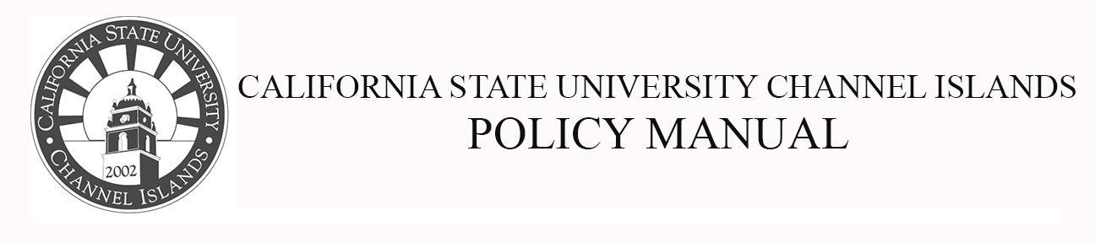
Division of Academic Affairs Policy Number: 17-xx
Approved By: Effective Date: AY 2018-19
Page 1 of 2

Language Graduation Requirement

POLICY #: SP 17-xx
Replaces Senate Policy (SP) 08-11.

Drafted by: Curriculum Committee: Jared Barton, Bob Bleicher, Blake Buller, Rachel Danielson, Jasmine Delgado, Blake Gillespie, Jeanne Grier, Mary Laurence, Kristen Linton, Jesse Paredes, Monica Pereira, Monica Rivas, Janet Rizzoli, Andrea Skinner

Purpose: The purpose of this policy is to bring SP 08-11 into alignment with the CSU Chancellor's Office Executive Order 1100 Revised, which will take effect in academic year (AY) 2018-2019, and CSUCI’s (CI’s) SPs 16-11 and 16-12, which will take effect in AY 2019-2020.

Background: CI’s General Education (GE) pattern prior to AY 2018-2019 had four sub-areas within Area C. These subareas were as follows: C1: Art, C2: Literature, C3a: Language, and C3b: Multicultural. Beginning in AY 2018-2019, CI’s GE pattern will have two sub-areas within Area C. These subareas will be as follows: C1: Arts, which will include courses from the Arts, Cinema, Dance, Music, and Theater, and C2: Humanities, which will include courses from Literature, Philosophy, and Languages other than English.

According to the previous Language and Multicultural Requirements Policy (SP 08-11), CI students would typically fulfill the Language Requirement by taking a course from GE Area C3a. Since this GE sub-area will no longer exist in CI’s GE pattern beginning in AY 2018-2019, this necessitated the revision of the previous Language and Multicultural Requirements Policy (SP 08-11).

Applicability: All CSUCI Undergraduate Students

Page 2 of 2

Policy Text: Students will meet the Language Graduation Requirement when they do one of the following:

- Earn a “C-” or better in a language other than English course from General Education (GE) Area C2: Humanities.
  - Note: Students who are GE-certified in Area C must still meet the Language Graduation Requirement.

- Demonstrate proficiency in a language other than English by earning a grade equivalent of “C-” or better in an upper-division language course.
  - Note: While students will meet the Language Graduation Requirement, they will not earn units in GE Area C2: Humanities.

- Demonstrate proficiency through one of the following examinations: Advanced Placement (AP), College-Level Examination Program (CLEP), International Baccalaureate (IB), or the American Council on the Teaching of Foreign Languages (ACTFL) Oral Proficiency Interview (OPI), or other examinations approved by the chair of the Global Language Program.

- Provide a high school diploma with a state-approved Seal of Biliteracy.
  - Note: While students will meet the Language Graduation Requirement, a state-approved Seal of Biliteracy does not earn college-level credit or units.

- Study abroad and earn a grade equivalent of “C-” or better in a native language course (other than English) in their host country.

- Complete the Defense Language Institute (DLI) program in accordance with SP 10-08.

- A high school diploma or equivalent or a transcript where the language of instruction at the school was in a language other than English. (pending chair approval)

