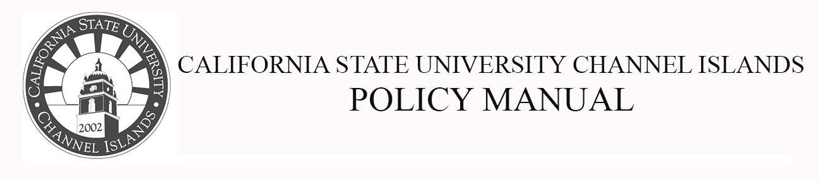
Division of Academic Affairs Policy Number: 17-xx
Approved By: Effective Date: AY 2018-19
Page 1 of 2

Multicultural Graduation Requirement

POLICY #: SP 17-xx
Replaces Senate Policy (SP) 08-11.

Drafted by: Curriculum Committee: Jared Barton, Bob Bleicher, Blake Buller, Rachel Danielson, Jasmine Delgado, Blake Gillespie, Jeanne Grier, Mary Laurence, Kristen Linton, Jesse Paredes, Monica Pereira, Monica Rivas, Janet Rizzoli, Andrea Skinner

Purpose: The purpose of this policy is to bring SP 08-11 into alignment with the CSU Chancellor's Office Executive Order 1100 Revised, which will take effect in academic year (AY) 2018-2019, and CSUCI’s (CI’s) SPs 16-11 and 16-12, which will take effect in AY 2019-2020.

Background: CI’s General Education (GE) pattern prior to AY 2018-2019 had four sub-areas within Area C. These subareas were as follows: C1: Art, C2: Literature, C3a: Language and C3b: Multicultural. Beginning in AY 2018-2019, CI’s GE pattern will have two sub-areas within Area C. These subareas will be as follows: C1: Arts, which will include courses from the Arts, Cinema, Dance, Music, and Theater, and C2: Humanities, which will include courses from Literature, Philosophy, and Languages other than English.

According to the previous Language and Multicultural Requirements Policy (SP 08-11), CI students would typically fulfill the Multicultural Requirement by taking courses from GE Area C3b. Since this GE sub-area will no longer exist in CI’s GE pattern beginning in AY 2018-2019, this necessitated the revision of the previous Language and Multicultural Requirements Policy (SP 08-11).

Applicability: All CSUCI Undergraduate Students

Policy Text: Students will meet the Multicultural Requirement when they take a course from the GE Committee-approved list of Multicultural Perspectives (MP) courses and earn a passing grade.

