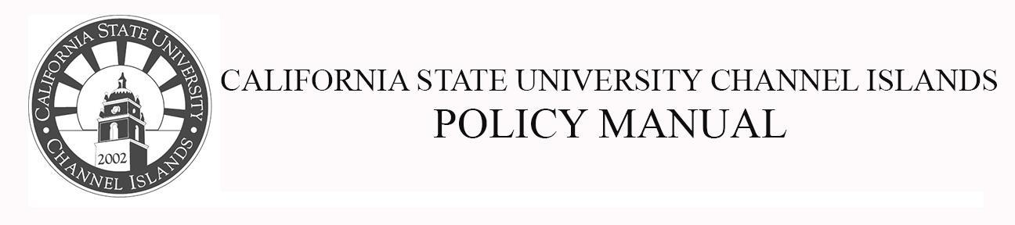
Division of Academic Affairs Policy Number: 17-xx
Approved By: Effective Date: AY 2018-19
Page 1 of 2

Language Graduation Requirement

POLICY #: SP 17-xx
Replaces Senate Policy (SP) 08-11.

Drafted by: Curriculum Committee: Jared Barton, Bob Bleicher, Blake Buller, Rachel Danielson, Jasmine Delgado, Blake Gillespie, Jeanne Grier, Mary Laurence, Kristen Linton, Jesse Paredes, Monica Pereira, Monica Rivas, Janet Rizzoli, Andrea Skinner

Purpose: The purpose of this policy is to bring SP 08-11 into alignment with the CSU Chancellor's Office Executive Order 1100 Revised, which will take effect in academic year (AY) 2018-2019, and CSUCI’s (CI’s) SPs 16-11 and 16-12, which will take effect in AY 2019-2020.

Background: CI’s General Education (GE) pattern prior to AY 2018-2019 had four sub-areas within Area C. These subareas were as follows: C1: Art, C2: Literature, C3a: Language, and C3b: Multicultural. Beginning in AY 2018-2019, CI’s GE pattern will have two sub-areas within Area C. These subareas will be as follows: C1: Arts, which will include courses from the Arts, Cinema, Dance, Music, and Theater, and C2: Humanities, which will include courses from Literature, Philosophy, and Languages other than English.

According to the previous Language and Multicultural Requirements Policy (SP 08-11), CI students would typically fulfill the Language Requirement by taking a course from GE Area C3a. Since this GE sub-area will no longer exist in CI’s GE pattern beginning in AY 2018-2019, this necessitated the revision of the previous Language and Multicultural Requirements Policy (SP 08-11).

Applicability: All CSUCI Undergraduate Students

Page 2 of 2

Policy Text:
Students will meet the Language Requirement when they do one of the following:

- Earn a “C-” or better in a language other than English course from General Education (GE) Area C2: Humanities.
  - Note: Students who are GE-certified in Area C must still meet the Language Requirement for graduation.

- Demonstrate advanced proficiency in a language other than English by earning a grade of “C-” or better in an upper-division language (e.g. Spanish) course.
  - Note: while students will meet the Language Requirement for graduation, they will not earn units in GE Area C2: Humanities.

- Demonstrate proficiency through one of the following examinations: Advanced Placement (AP), College-Level Examination Program (CLEP), International Baccalaureate (IB), or the American Council on the Teaching of Foreign Languages (ACTFL) Oral Proficiency Interview (OPI).

- Provide a high school diploma with the California State Seal of Biliteracy on it.
  - Note: while students will meet the Language Requirement for graduation, they will not earn college-level credit or units.

- Study abroad and earn a “C-” or better in a native language course (other than English) in their host country.

- Complete the Defense Language Institute (DLI) program in accordance with SP 10-08.

