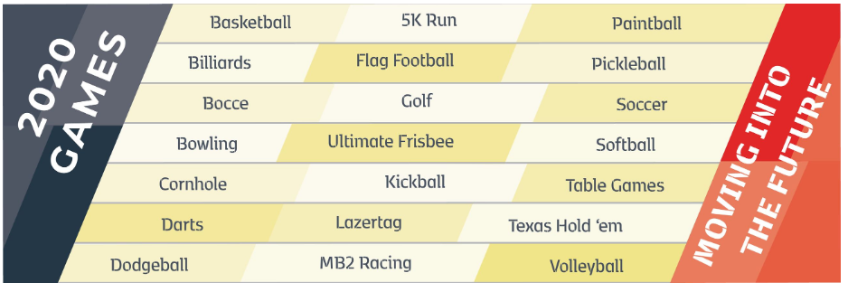

Tentative Schedule (to be finalized the second week of March 2020)
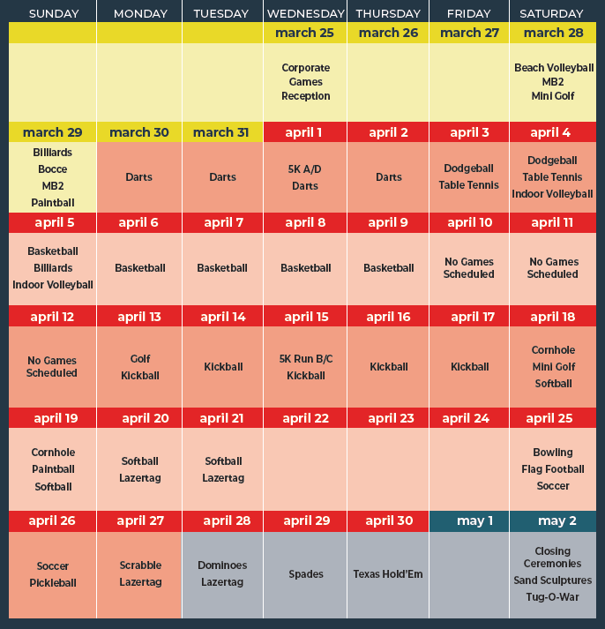
2020 Corporate Games Registration is now open
November 15, 2019 - Registration is now open for the City of Ventura's 31st annual Corporate Games competition and CSUCI is looking forward to participating again! Held March 21 through May 2, the Corporate Games features a number of sporting events to participate in, and registration is open to all CSUCI employees (faculty, staff and auxiliary), contractors, consultants, temporary employees, and student workers (over the age of 18 who work more than 20 hours weekly).
This year we will compete against other teams in Division B and our goal is to participate in 16 sporting events, the opening ceremony, photo contest, beach cleanup, sand sculpture, and closing ceremony. This marks our eighth consecutive year of participation and we want to thank President Beck for agreeing to cover the cost of registration for the Games. We would also like to thank Communication & Marketing for covering the cost of our 2020 team shirts.
Speaking of team shirts, we are looking for design ideas that speak to who we are and reflect this year’s theme, “Moving into the Future.” Contact Melissa Bergem.
Additional information regarding details such as 5K bib and basketball jersey pick-up will be made available prior to each event. All other details and a full list of sporting events open to participants is available on the CSUCI Corporate Games website.
Visit https://www.csuci.edu/staff/council/corporate-games/ to register.
For more information contact Melissa Bergem at 805-437-3557 or melissa.bergem@csuci.edu.

